FAQs

To ensure you can follow along with my video tutorials as closely as possible, use the *same version of Unity*. The version number can be seen in the videos at the top of the screen:

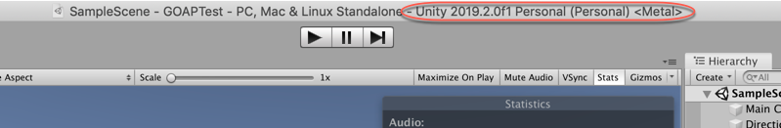

Unity is constantly evolving and while the temptation to update to the latest version may be great, real-world development teams never update in the middle of a project, for fear of introducing compatibility issues they weren't expecting.

The version of Unity you use will not affect the viability of your product.